Date: 2022-11-12

Group MHA

Murtadha Alobaidi , mhaao@kth.se

Hasan Alzubeidi , haz@kth.se

Ahmed Alkhalaf, ahmedalk@kth.se

1) When a process creates a new process using the fork() operation, which of the following states is shared between the parent process and the child process? Stack, Heap, or Shared memory segments?

Answer:   
**Shared memory segments**

2) Explain what the output will be at LINE A.

Answer: **LINE A = 15**

3) How many processes are created in the following code?

Answer: **8**

4) See Section 4.1 of the “Operating Systems Concepts” book. Does the multithreaded web server described in that section exhibit task or data parallelism?

Answer:

**Data parallelism**

5) What are two differences between user-level threads and kernel-level threads? Under what circumstances is one type better than the other?

Answer:

* The kernel does not know the **User-level threads** but the kernel know the User-level threads.
* The user thread is always belong to the process but the case is different with kernel thread.
* **User-threads** is better because the kernel threads its more expensive to maintain the kernel thread.

6) Describe the actions taken by a kernel to context-switch between kernellevel threads.

Answer:

* When switching out from a thread: Save CPU-registers value.
* When scheduling new thread: restoring CPU-registers value.

7) Explain the difference between preemptive and nonpreemptive scheduling.

Answer:

* preemptive: Preemptive scheduling makes the interruption of the process possible when the execution of the process is in the middle.
* Nonpreemptive: The intribution is only possibly when the execution of the process is completed.

8) Suppose that the following processes arrive for execution at the times indicated. Each process will run for the amount of time listed. In answering the questions, use nonpreemptive scheduling, and base all decisions on the information you have at the time the decision must be made.

Answer:

1. A the average turnaround time for **FCFS by use nonpreemptive scheduling**  = (8-0)+(12-0,4)+(13-12) / 3 = **10,53**
2. The average turnaround time for these processes with the **SJF** scheduling **by use nonpreemptive scheduling**  = (8-0)+(9-1)+(13-0,4) / 3 = **9,53**
3. The SJF algorithm the average turnaround time will be if the CPU is left idle for the first **1 unit** = (1-1) + (6-0,4) + (15 -0) / 3 = **6,86**

9) Consider the following set of processes, with the length of the CPU burst time given in milliseconds.

Answer:

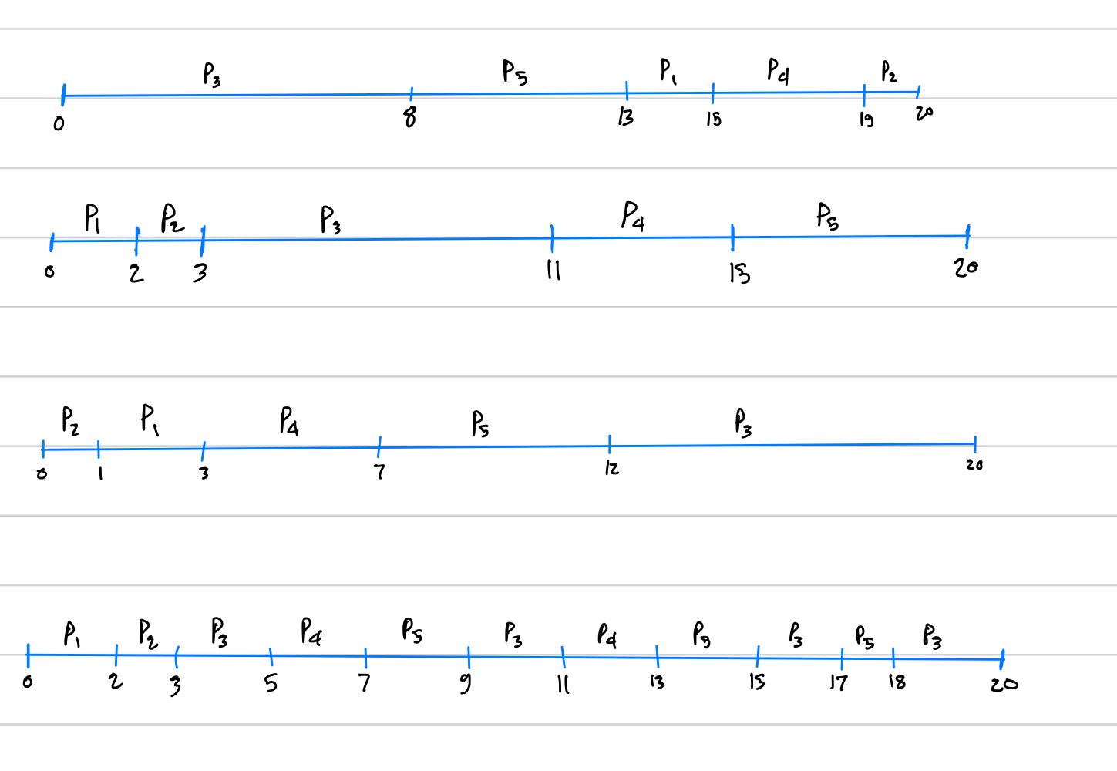

1. And c) The arrival time 0
   1. RR

|  |  |  |
| --- | --- | --- |
|  | turnaround time | Waiting time |
| P1 | 2 | 0 |
| P2 | 3 | 2 |
| P3 | 20 | 12 |
| P4 | 13 | 9 |
| P5 | 18 | 13 |

* 1. Priority

|  |  |  |
| --- | --- | --- |
|  | turnaround time | Waiting time |
| P1 | 15 | 13 |
| P2 | 20 | 19 |
| P3 | 8 | 0 |
| P4 | 19 | 15 |
| P5 | 13 | 8 |

* 1. FCFS

|  |  |  |
| --- | --- | --- |
|  | turnaround time | Waiting time |
| P1 | 2 | 0 |
| P2 | 3 | 2 |
| P3 | 11 | 3 |
| P4 | 15 | 11 |
| P5 | 20 | 15 |

* 1. SJF

|  |  |  |
| --- | --- | --- |
|  | turnaround time | Waiting time |
| P1 | 3 | 1 |
| P2 | 1 | 0 |
| P3 | 20 | 12 |
| P4 | 7 | 3 |
| P5 | 12 | 7 |

d) The minimum average waiting time (over all processes)

a)RR = 7,2

b) Priority = 11

c)FCFS = 6,2

d) SJF 4,6

**The answer is SJF**

**SOURCES:**

(ABRAHAM SILBERSCHATZ, 2018)